AUXDATA II : Activity Log Entry Quick Guide
(Note: The detail screen grid below provides reminder of the entries you need to check before submittal)
- From the Navigation Bar on the Top of your Home Page, Click “Activity Logs”
- A list will appear (Recently Viewed is the default). Click NEW on the upper right above the list.
- In the next pop-up, click “Activity”
Detail Screen:
Left Side of Screen |  |  |  | Right Side of Screen
√ | Data Element | Instruction |  | √ | Data Element | Instruction
o | Unit | Start Typing in Flotilla Name then pick from list |  | o | Review Status | This will say “open” until you click “Submit”
o | Activity Type | Select “Activity” |  | o | Operations Code | Pick from the drop down if appropriate
o | OPCON- | If a general activity start typing “First District” then pick First District Northern from the list. If at a Station, start typing the station name starting with STA to find it or scroll the list. |  | o | Mission Code | Pick from the drop down or enter the number and pick from the list that comes up
 |  |  |  | o | Mission Location | Skip this- leave blank
 |  |  |  | o | Mission Start Date | Enter the date
 |  |  |  | o | Mission Start Time | This defaults to 12pm- you do not need to change it
 |  |  |  | o | Duration | Enter the hours and decimal hours for the mission
 |  |  |  | o | Remarks | Any comments or remarks you wish to enter
Scroll Down
These next rows are to be used for activities that are reported with counts (VE, UPV, PE, etc. Provide the information as appropriate for the mission code used.
Vessel Examination
# Exams Given |  |  |  | # First Time
# Exams Passed |  |  |  | # High Focus
Program Visits
# Program Visit
ATON Verification
# ATON Discrepancies |  |  |  | # ATON Watching Properly
Public Education (only enter with last class/ exam)
# Enrolled |  |  |  | # Enrolled Under 17
# Completed |  |  |  | # Completed under 17
State
 | Public Affairs
# Persons contacted |  |  |  | Event Description
 |  |  |  | o | Remarks | Enter comments to briefly describe the mission
o | Activity Approvers | If blank, enter the FSO Name (can start to type and pick from list) and SO Name.
 |  |  |  | o |  | Click SAVE

- After you click “Save” you will see what you entered along with a Navigation Bar on the Left and an “Action” bar on the right.
Activity Log Navigation:
DETAIL RELATED MEMBER ASSIGNMENT TASK CAPTURE
Member Assignment Screen:
o The Member List is on the top of the screen, members assigned to this activity log will identified at the bottom of the screen.
- Select one of the unit type buttons (e.g. Flotilla, Division, District etc.) or select from “ALL”
- Search the member by entering the member number or name in the box at the top.
- Put a check mark in the box to the left of the member’s name that you want to assign to the mission
- Click “Add Member” Blue button to move that name into the space at the bottom.
- Repeat for additional Members on the mission
- Change the Default Position to Lead or Trainee as needed (default is non-lead).
- When done, click the Green “Update Activity Member” Button.
Task and Task Capture Screens: ****Workshops Only****
Most workshops are entered by the DIRAUX Office or their designees but if you happen to need to enter an in-classroom Core Training or Operations workshop, you will need to do the following.
- Enter the Detail Information as described Previously
- Enter the Member assignment including identification of the lead instructor and the other members who participated as Trainees.
- Go to Related and scroll down to the TASKS section. Click the “New” button on the far right. In the pop up, Pick the workshop from the Drop-down list under tasks and click SAVE
- Go to the task capture screen. Click the button to the left of the task. That will populate the table below with names from the member assignment. Leave all the names checked (check box to left of each name). Click Green “Assign Tasks to Members” button.
READY to SUBMIT?????
- The Activity Log Status will be “open” until submitted. Once submitted the log is locked.
- In the Upper Right of all screens there is an Action Bar- Click the “Submit for Approval” button.
- You have the ability to add additional comments here as well.
- Once submitted, you will see the status change to “Under FSO-IS Review”

COPY Mission with Crew
- In the Action Bar there is a Carrot Symbol (▼)
- Click on the Symbol and pick “Clone” from the drop down.
- Edit the cloned record as appropriate and submit.
Recall Submittal
- Want to withdraw the submittal?
- Locate the Activity log you wish to recall and click on the AL-# link to open it
- Go to the RELATED section
- Scroll down to Approval History
- Click on the RECALL button on the far right

IS Officer only ACTIVITY LOG REVIEW/ APPROVAL
Creating a Custom list of Activity Logs requiring your review
From the Main Activity Log Screen
- Click the down arrow next to the Activity Log header.
  - One of the selections will be “Activity Logs Requiring my approval GEN”
  - Click on this one to open it.
- Go to the Action bar on the upper right and Click “Clone”
- Go to the filters Add a filter to have Status = Under FSO IS Review.
- Add a second Filter to have the FSO IS Name = Your name
- PIN this report- this will mean that each time you access the Activity Log Object, you will open with your list of things needing review.
You can also link to an activity log requiring approval from the email you will receive when a member submits.
How to Review and Approve or Reject an Activity Log
- There are 2 ways to get to the activity log that may be awaiting your approval
  - When you get the email, click on the link in the email
  - Pick the Activity Log off you list view (click on the AL-#)
- Open the activity log
  - Check the Detail Screen- is all data complete? Is the activity code correct?
  - Check the member assignment- have members been assigned? Do they show the correct position?
- Go to the Related Screen
  - Go to the activity Approval History
  - Click Approve or Reject. If Rejected the status will change to “Needs Clarification” and the form will be returned to the control of the member. You will be prompted to add comments or questions for which you seek clarification.
  - Click the AL-# again to go back to the detail screen. You will see the status has changed.

SCREEN SHOTS OF ACTIVITY LOG ENTRY SCREENS
In the following pages, screen shots have been prepared to walk through the process.
The Initial Activity Log Screen
To start and entry click on “New”
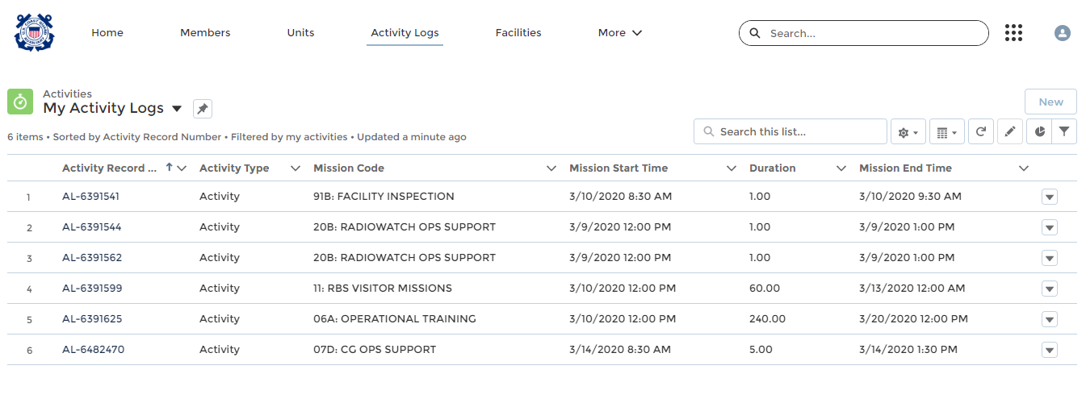
Select Unit/ Individual
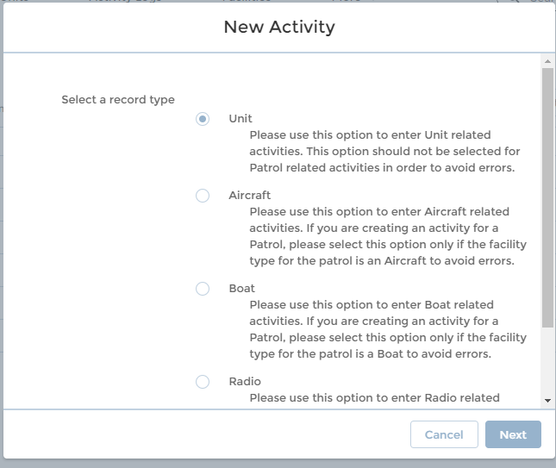
Detail Screen Top part (see previous Entry Instruction)
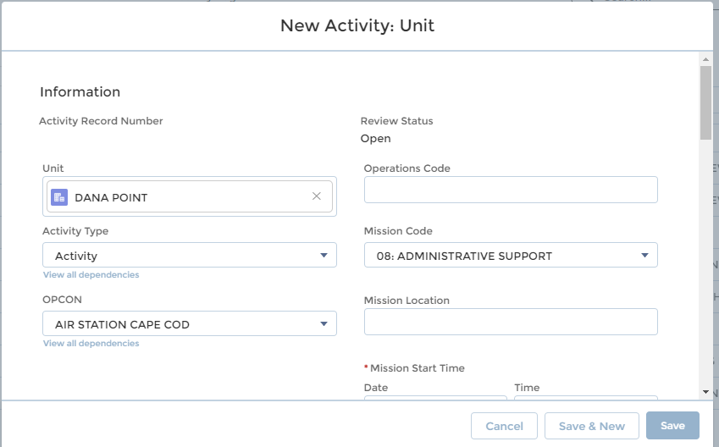
More of the Detail Screen (Scroll Down)
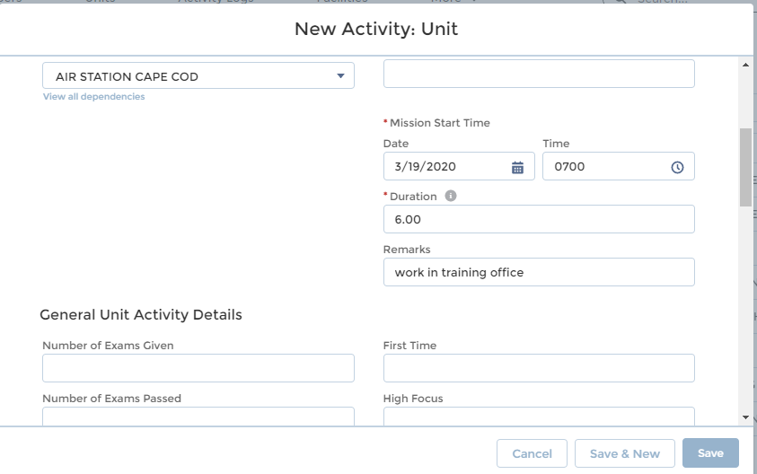
Scroll down and Check the FSO and SO Approvers are correct
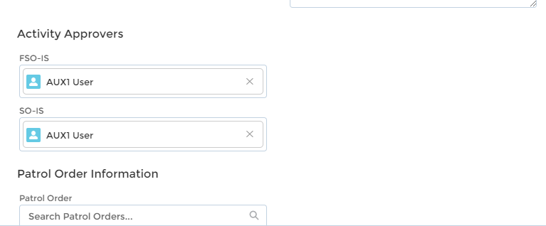
Click SAVE
See Navigation Bar in upper left- Click on Member Assignment
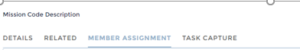
Member Assignment- Search for members on the mission by name or Member #

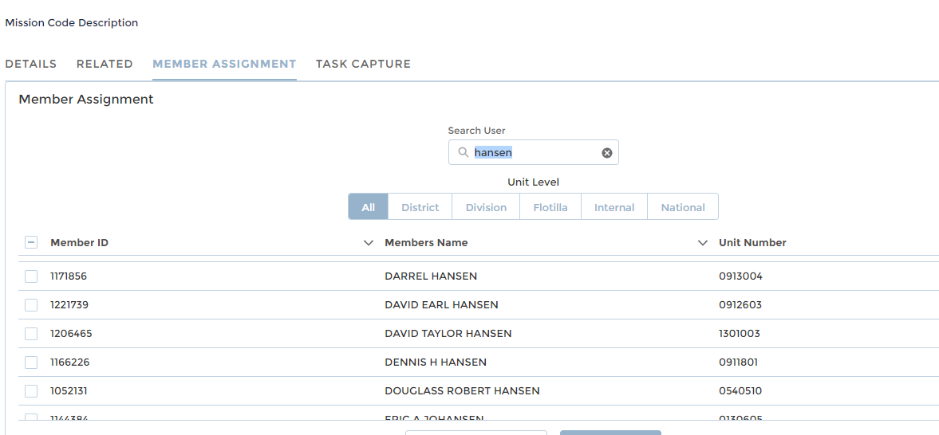

Click on the box to the left of the name and then the blue button to assign the member to the mission. 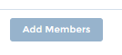
Same Screen (scroll down)- When the correct members have been assigned and the positions assigned (Lead, Non-Lead, etc.), Click the Green Button to complete the transaction.
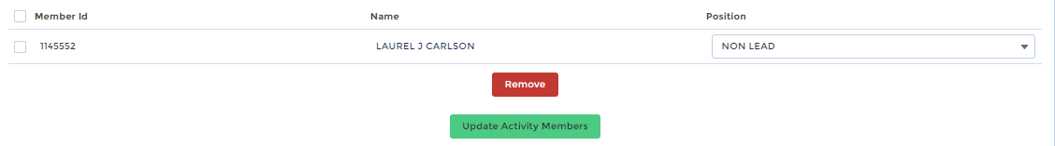

SUBMIT- Upper Right Action Bar (no screen shot)- Click Submit for Approval.
