How to Set up Your Own Page in AUXDATA II
- Look at the Navigation Bar at the Top of the Home Page- Click on MEMBERS

- Once on Members, click on Drop Down arrow upper left and select “All Active Members” | 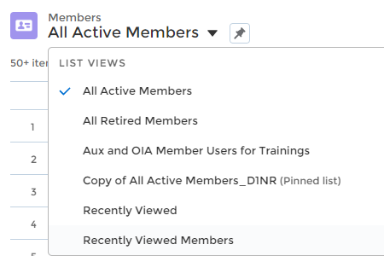
- On ‘All Active Members” page, click on the gear icon on the Right and select “Clone” from the list that pops up. | 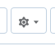
- A new window will pop up to allow you to save this to your folder – rename it to “My Member Page” | 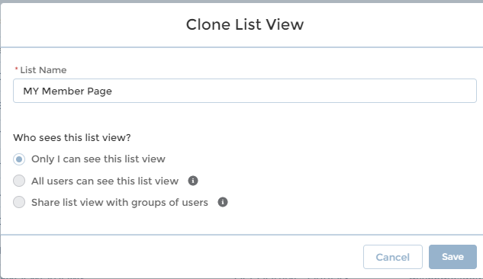
- Next- add a filter to customize the list. Click on the icon on the right that looks like a funnel.

- In the Member ID Filter, make the value your Member ID (Delete the Unit filter) | 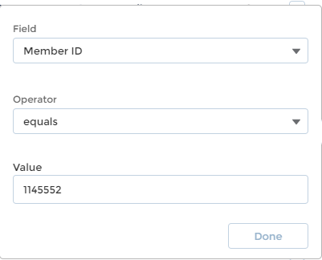
- Click DONE and SAVE

- Click the refresh button (little circular arrow upper left)

- Pin this page using the little pin icon (on left)

- Every time you click the MEMBERS link on the navigation bar, you will come back to this page.

Laurel J. Carlson, DSO-IS, D1NR 12 May 2020

