AUXDATA II: Activity Log Entry Quick Guide: ANSC 7029 Member Hours
NOTES:
- This describes the procedure for entry of Member Hours only (99A, 99B, 99D, etc.). A member is NOT required to submit Member hours using the system- they can choose to continue with submittal of the ANSC7029 to their FSO-IS.
- One Activity Log must be completed for each Member Hours Activity Code (e.g. if submitting 99A hours, 99B, Hours and 99D hours, you must submit three Activity Logs.
- Miles and Unreimbursed cost are for the 99 codes in total and should be submitted on only ONE of the activity logs submitted (not all).
- The REMARKS section in the new form should be used at all times to describe what kinds of activities are included in the hours reported. This is the only way the FSO-IS can quality control the submittal. Failure to insert Remarks may result in the form being returned for clarification.

- From the Navigation Bar on the Top of your Home Page, Click “Activity Logs”

- A list will appear (Recently Viewed is the default). Click NEW on the upper right above the list.
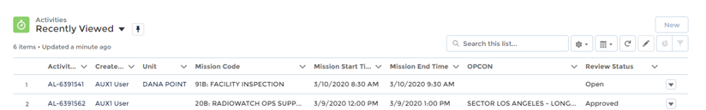
- In the next pop-up, click “Activity”

Detail Screen Entry:
Left Side of Screen |  |  |  | Right Side of Screen
√ | Data Element | Instruction |  | √ | Data Element | Instruction
o | Unit | Start Typing in Flotilla Name then pick from list |  | o | Review Status | This will say “open” until you click “Submit”
o | Activity Type | Select “Activity” |  | o | Operations Code | Only AUXCHEF would be used for food service activity at AUX events only
o | OPCON- | For Member Hours start typing “First District” then pick First District Northern from the list. |  | o | Mission Code | Enter 99A, 99B, 99C, 99D or 99E as appropriate
 |  |  |  | o | Mission Location | Skip this- leave blank
 |  |  |  | o | Mission Start Date | Enter the date- usually the last day of the month or quarter for which you are reporting
 |  |  |  | o | Mission Start Time | This defaults to 12pm- you do not need to change it
 |  |  |  | o | Duration | Enter the hours and decimal hours for the mission
 |  |  |  | o | Remarks | In the remarks briefly describe what you did in those hours (e.g. travel and prep for PE class, attend Division mtg, Attend Flotilla Mtg, etc.) There is plenty of space
Scroll Down to the bottom and click “SAVE”

- After you click “Save” you will see what you entered below a form Navigation bar on the left that has the following tabs:
Click on Member Assignment
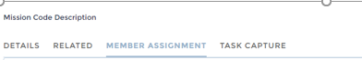

Skip to the Member Assignment Tab:
The Member List is on the top of the screen, members assigned to this activity log will identified at the bottom of the screen.
- The system defaults to “ALL” (other buttons not working)
- Search the member by entering the member number or name in the box at the top.
- Put a check mark in the box to the left of the member’s name that you want to assign to the mission
- Click “Add Member” Blue button to move that name into the space at the bottom.
- Change the Default Position to Lead
- When done, click the Green “Update Activity Member” Button.
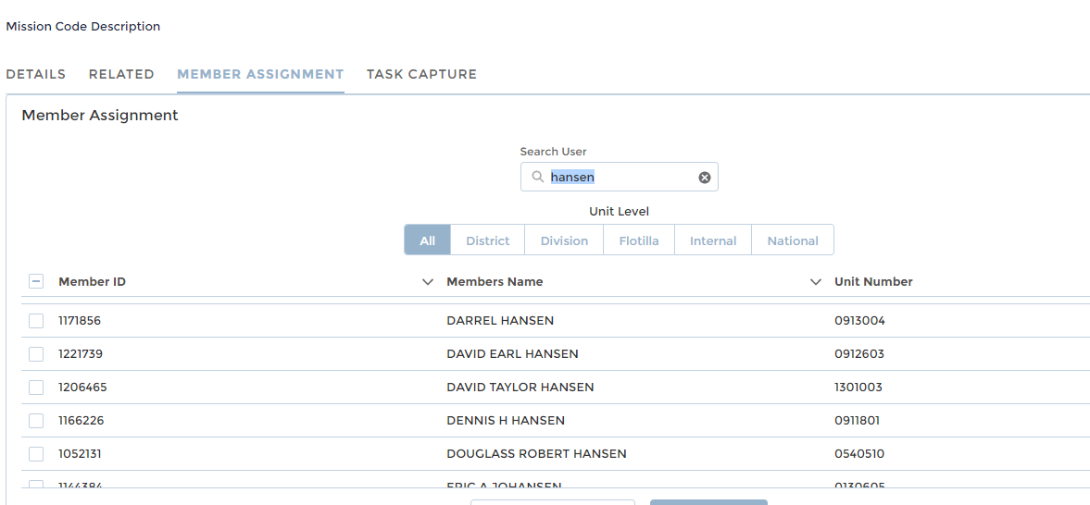
Click on the box to the left of the name and then the blue button to assign the member to the mission. 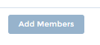
Same Screen (scroll down)- When the correct members have been assigned and the positions assigned (Lead, Non-Lead, etc.), Click the Green Button to complete the transaction.
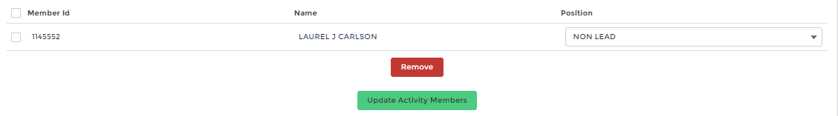
Ready to SUBMIT?
- The Activity Log Status will be “open” until submitted. Once submitted the log is locked.
- In the Upper Right of all screens there is an Action Bar- Click the “Submit for Approval” button.
- You have the ability to add additional comments here as well.
- Once submitted, you will see the status change to “Under FSO-IS Review”
SUBMIT- Upper Right Action Bar (no screen shot)- Click Submit for Approval.
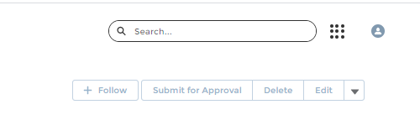

COPY Mission with Crew- Adding another form for a second (third, fourth 99 code)
- In the Action Bar (upper right) there is a Carrot Symbol (▼)
- Click on the Symbol and pick “Clone” from the drop down.
- Edit the cloned record as appropriate. Make sure to include the Flotilla, the new code you wish to report and the duration. When done, click the “Submit” button on the action bar.
Recall Submittal
- Want to withdraw the submittal?
- Go to the Activity Log Start page and look at “Recently Viewed”
- Locate the Activity log you wish to recall and click on the AL-# link to open it
- Go to the RELATED section in the form
- Scroll down to Approval History
- Click on the RECALL button on the far right

